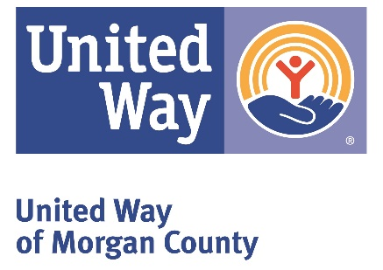

March 20, 2020

Dear Friends,
As our community begins to feel the effects of the COVID-19 crisis, United Ways across Alabama are taking action.

In partnership with local governments, businesses, and non-profits, we are launching Community Crisis Funds to allow you to join us in supporting those affected, with a focus on:
Feeding People
Providing Emergency Assistance
(utility bills, eviction avoidance and other urgent needs)
Supporting Distressed Agencies
It's easy to feel helpless - but you can help. By donating to the United Way of Morgan County – Community Crisis Fund, you are providing agencies in Morgan County with the resources they desperately need to keep our most vulnerable neighbors healthy.

To help our community through this crisis, please make a tax-deductible donation today by sending your check to:

United Way of Morgan County – CCF
PO Box 1058
Decatur, AL, 35602

Or make your donation online at www.uwmcal.org by clicking on the Community Crisis Fund donation button or directly by clicking on this link UWMC Community Crisis Fund.

If you or someone you know is in need of information or assistance, please call 211 or visit www.211ConnectsAlabama.org, United Way of Morgan County’s Information and Referral Service.

Or visit our website at www.uwmcal.org to view a growing list of service updates.
Thank you for your support, and stay healthy!

Kathleen Ross
President and CEO

